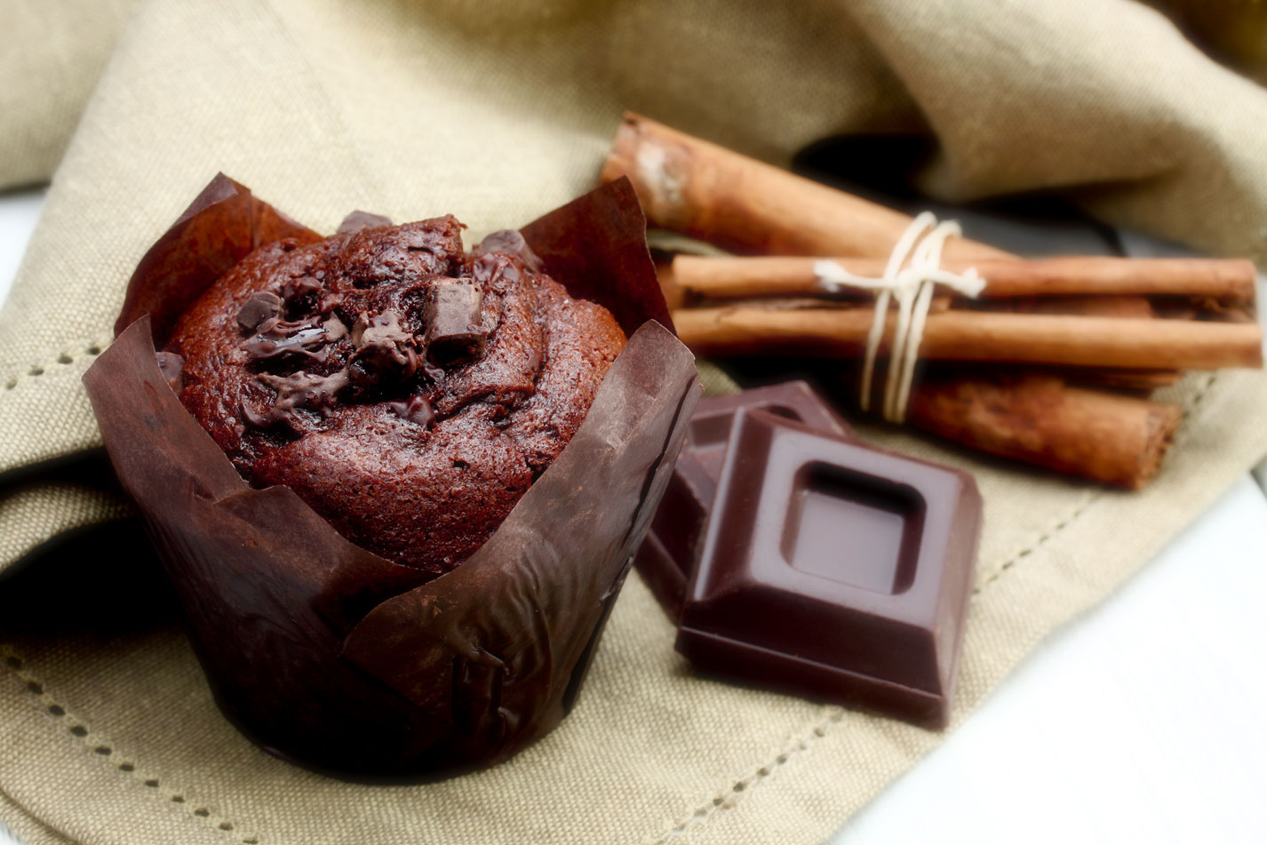

**TIME**

PREP 25M COOK 30M

**INGREDIENTS**

2 1/4 cups self-raising flour, sifted

1/2 cup cocoa powder, sifted

1 cup caster sugar

3/4 cup dark chocolate chips

1/2 cup vegetable oil

2/3 cup milk

1 teaspoon vanilla extract

2 eggs

Chocolate **Muffin**

Step 1

Preheat oven to 180°C/160°C fan-forced. Line a 12-hole, 1/3 cup-capacity muffin pan with paper cases.

Step 2

Combine flour, cocoa, sugar and chocolate chips in a large bowl. Make a well in centre. Whisk vegetable oil, milk, vanilla and eggs in a large jug. Add oil mixture to well (see Cooking class, below). Using a wooden spoon, stir until just combined (don't over-mix). Spoon mixture into paper cases.

Step 3

Bake for 25 minutes or until firm to touch and a skewer inserted into the centre comes out clean. Stand in pan for 5 minutes. Transfer to a wire rack to cool. Serve.